## **Objectives**

* Define Props
* Explain Default Props
* Identify the differences between State and Props
* Explain reactDOM.render()

In this hands-on lab, you will learn how to:

* Use Props
* Apply reactDOM.render()

## **Prerequisites**

The following is required to complete this hands-on lab:

* Node.js
* NPM
* Visual Studio Code

## **Notes**

Estimated time to complete this lab: **60 minutes.**

Create a React Application named “shoppingapp” with a class component named “OnlineShopping” and “Cart”.

1. In Cart class, create 2 properties as mentioned below:

* Itemname
* Price

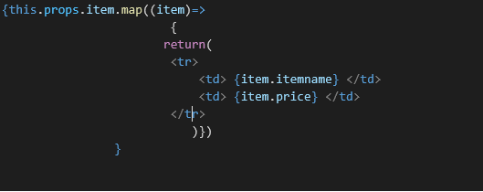

1. In OnlineShopping class, create an array of Cart and initialize 5 items.

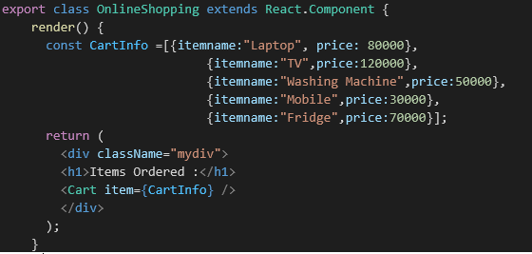

1. Loop through these items and display the data as shown below:

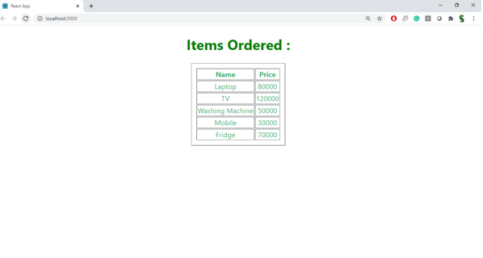

**Output:**

